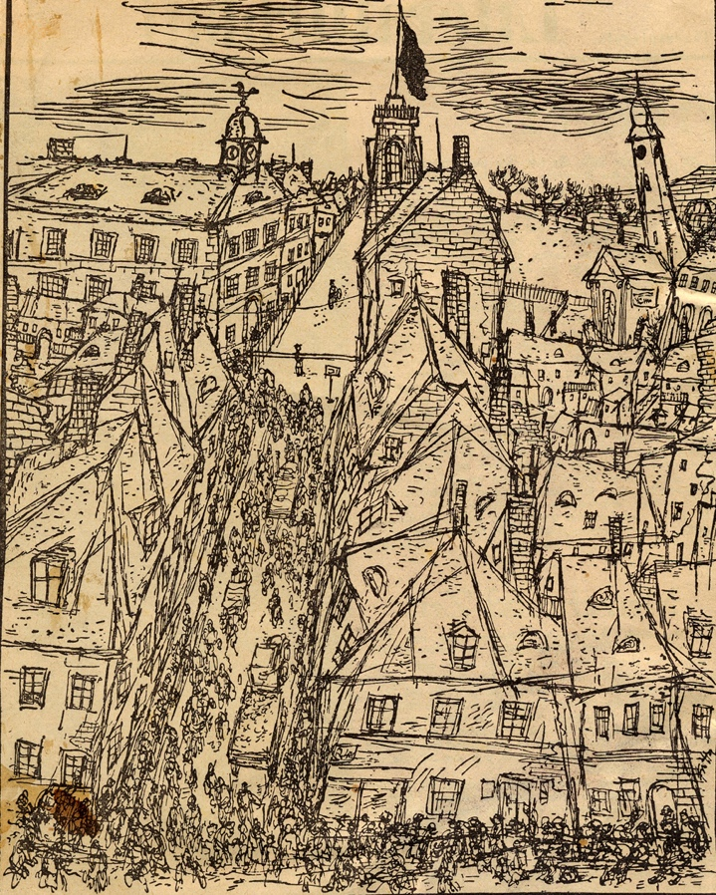
Bedřich Fritta, A View of Terezin, 1941-1944, Public domain, via Wikimedia Commons

Europe and the USSR.
Literature in the face of the persecution and extermination of the Jews

22 March 2024
Location: Wiener Wiesenthal Institut für Holocaust-Studien
Rebensteig 3, Wien, Austria


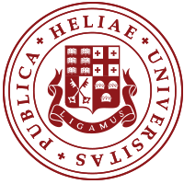

„[…] die Verzweiflung über Deutschland berghoch auf meiner Brust. Die Frage ist: Überlebt man’s? “ (« […] the despair of Germany weighs heavily on my chest. The question is: will we survive? »). The author of this lines, Jacob Wassermann, was one of the many German writers whose books were burned by the Nazis. He died in exile in Altaussee, Austria, in 1934, before it was annexed by Nazi Germany. In 1933, he wrote Selbstschau am Ende des sechsten Jahrzehnts, which indicted German anti-Semitism.

The workshop’s purpose is to examine the literary, artistic, musical and cinematographic responses to the rise of anti-Semitism in the 1930s, which led to the systematic persecution and extermination of Europe’s Jews. It will focus on the period before the war, as well as after the war. This will allow us to consider, on one hand, the capacity of literature (and other media) to project an aftermath as a consequence of ongoing events, but also the aftermath as it was felt in the years following the Shoah. Thus, Georges Duhamel discussed the extermination of European Jews in his 1938 article. Likewise, Klaus Mann criticized the attitude of European democracies towards Hitler, whom he called “the scarecrow assassin” in the early 1930s. Mann emphasized the need to “reject” the “psychology” of “these people” and not to try to “understand” them (1931). In the aftermath of World War II, Vladimir Nabokov reflected on Holocaust denial in Western society during his exile (April 1945). Paul Celan composed Der Sand aus den Urnen (The Sand from the Urns), published in Vienna in 1948, invoking the victims of the camps. Meanwhile, Boris Slutsky, who was born in Ukraine, wrote his poems about the Shoah immediately after the war. During the war years, Ilia Erenburg and Il'ia Sel'vinskii had already written about the subject. These issues lead us to an aftermath in the sense of the aftermath of Auschwitz. While this aspect has been researched by scholars from various fields, there remain gaps, specifically in connection with the Soviet and post-Soviet space. What was the response or capability of writers who were subjected to censorship during the Stalinist and post-Stalinist regimes? How do authors depict the re-emergence of anti-Semitism in the Soviet Union and European countries in the decades before and after the Second World War in their literary (artistic) works? This workshop aims to raise initial questions on a vast subject that is still very under-explored in certain areas and from certain perspectives, such as minor literature and forgotten writers.

Organisers
Anke Bosse (Universität Klagenfurt/Musil-Institut/Kärntner Literaturarchiv)
Atinati Mamatsashvili (Ilia State University / Wiener Wiesenthal Institut für Holocaust-Studien)

Scientific commetee
Anke Bosse (Universität Klagenfurt, Musil-Institut/Kärntner Literaturarchiv)
Mzaro Dokhtourishvili (Ilia State University)
Atinati Mamatsashvili (Ilia State University / Wiener Wiesenthal Institut für Holocaust-Studien)
Arvi Sepp (Vrije Universiteit Brussel)
Bela Tsipuria (Ilia State University)
Marianne Windsperger (Wiener Wiesenthal Institut für Holocaust-Studien)
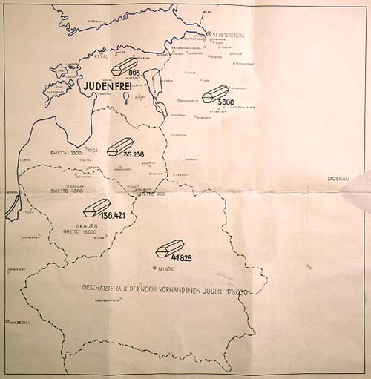

Franz Walter Stahlecker (1900–1942), Public domain, via Wikimedia Commons
Map entitled Jewish Executions Carried Out by Einsatzgruppe A, used to illustrate Stahlecker's report to Heydrich on January 31, 1942. Stamped “Secred Reich Matter”. Held in the Latvian State Historical Archives, Riga.

Programme

9h00 – 9h15 Opening

Marianne Windsperger (Wiener Wiesenthal Institut für Holocaust-Studien)
Anke Bosse (Universität Klagenfurt, Musil-Institut/Kärntner Literaturarchiv)
Atinati Mamatsashvili (Ilia State University / Wiener Wiesenthal Institut für Holocaust-Studien

9h15 – 10h15 Session 1 – Facing the Holocaust – facing the History
Moderator: Anke Bosse

Maxim D. Shrayer (Boston College) – The 1943 Krasnodar Trial and the Trials of Ilya Selvinsky's Poetic Reportage

Olaf Terpitz (University of Graz) – Babi Yar as Prism

10h15 – 11h15 Session 2 – Denouncing through the language, through poetic writing
Moderator: Elana Shapira

Arvi Sepp (Vrije Universiteit Brussels) – Jewish Language Criticism in 1933: Victor Klemperer’s and Karl Kraus’ early discursive analysis of anti-Semitism in the Third Reich

Anke Bosse (Universität Klagenfurt, Musil-Institut/Kärntner Literaturarchiv) – Paul Celan, survivor of the « bloodlands » : a poet and his poetry in transition

11h15 – 11h45 Coffee Break

11h45 – 12h45 Session 3 – Places, Spaces and Memory
Moderator: Olaf Terpitz

Alexandra Birch (Wiener Wiesenthal Institut für Holocaust-Studien) – Beregovsky, Weinberg, and Shostakovich: Negotiating Jewishness in the USSR

Rafi Tsirkin-Sadan (The Open University of Israel) – Place and Memory in Grigorii Kanovich’s Devil’s Spell

12h45 – 14h30 Lunch

14h30 – 15h30 Session 4 – Literary representations of destruction and anti-Semitism
Moderator: Marianne Windsperger

Elana Shapira (University of Vienna / University of Applied Arts Vienna) – Antisemitism and the “Shock of Bodily Intimacy” in Viennese Literature and Art of the Early 20th Century

Atinati Mamatsashvili (Ilia State University / Wiener Wiesenthal Institut für Holocaust-Studien) – The Inhabited Space as an Altered Space (Jacob, Frenkel)

15h30 – 16h Coffee Break

16h – 17h30 Session 5 – ‘Alternative temporalities’ – the present, the past, the aftermath
Moderator: Bela Tsipuria

Enikő Darabos (Sigmund Freud Private University Vienna) – Body and Trauma in ‘Parallel Stories’ from Péter Nádas

Harriet Murav (University of Illinois at Urbana-Champaign) – A Reprieve from Aftermaths: David Hofshteyn’s ‘And again a world’

Marat Grinberg (Reed College) – Writing Science Fiction in the Aftermath of Babyn Iar and Auschwitz: from Stanislaw Lem to Ariadna Gromova

